Distributed Optimization for Machine Learning

School of Electrical and Computer Engineering

University of Tehran

Erfan Darzi

Lecture 2 – Convex Optimization

erfandarzi@ut.ac.ir

# Recap

* Global and local optimality for unconstrained optimization
* Necessary and sufficient optimality conditions
* Difference between convex and non-convex optimization
* Convexity + optimality condition è Global optimality

Convex Optimization Problem?

**Convex function Convex Set**

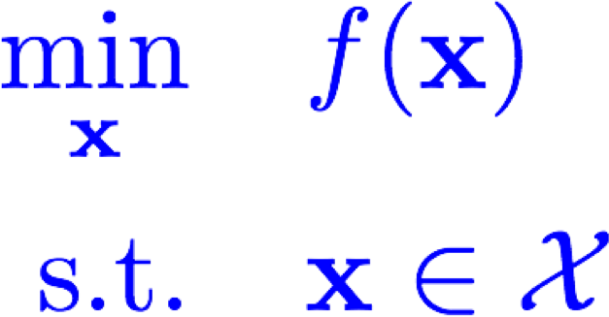

* Is a given function convex?
* Is a given set convex?

How to identify a convex function?

* Definition: 

**(Very useful definition: Jensen’s inequality)**

* Hessian for twice differentiable functions:

**Examples:**

* Affine functions:

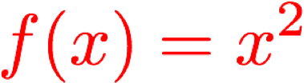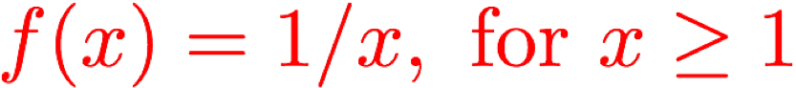

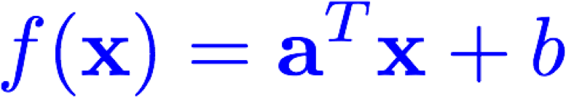

* Quadratic functions:



Convex Functions

* Norms:**Examples:**

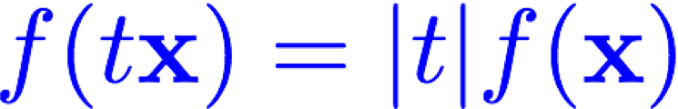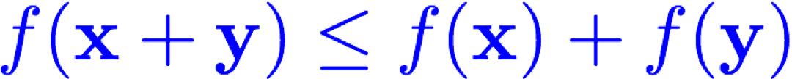

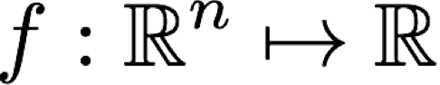is a norm if



Special cases



* A function is convex iff it is convex on every line:



* Positive multiple of convex function 
* Sum of convex functions:  Extension to integral

# Convex Functions

* Pointwise supremum of convex functions

Example

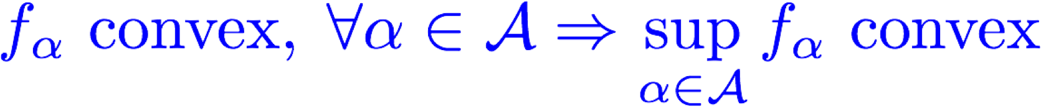 **No assumption on** 

* Affine transformation of domain



•

•

Composition:



Necessary?

•

Examples of Convex Functions on Matrices

* Affine function: 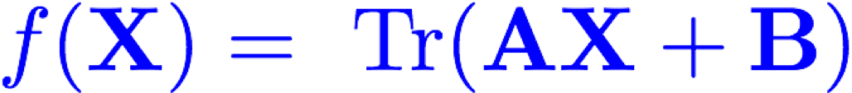
* Largest eigenvalue on symmetric matrices: 
* Largest singular value: 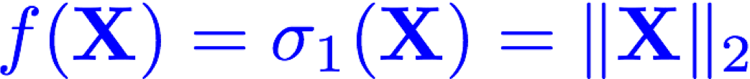

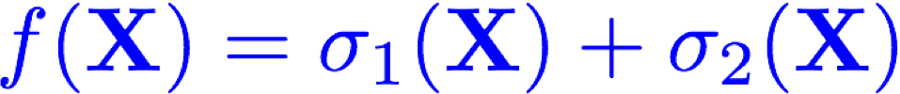

* Log-det-inv on PSD matrices 

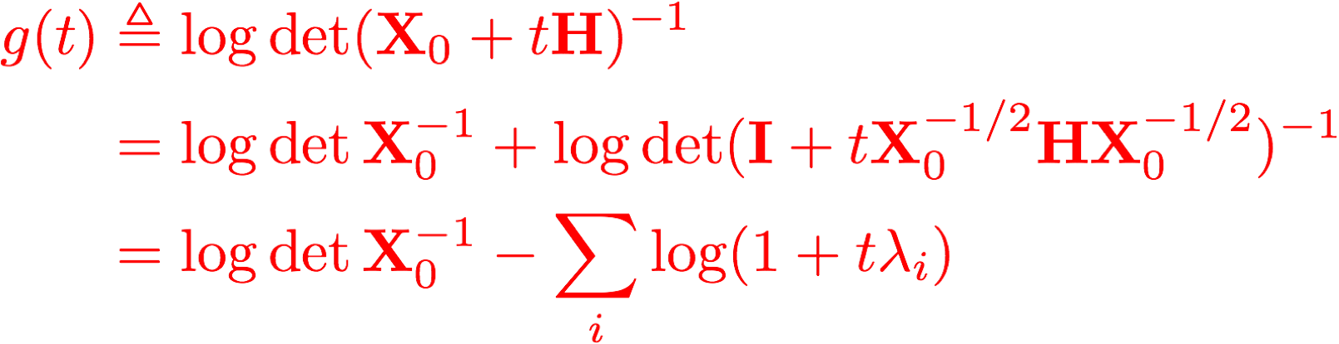

# From Convex Functions to Convex Sets

* A sublevel set of a convex function is convex set



**Is the converse true?**

Examples of Convex Sets

* 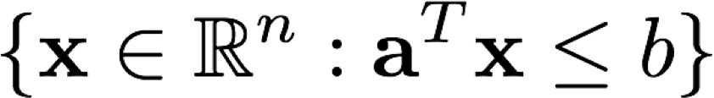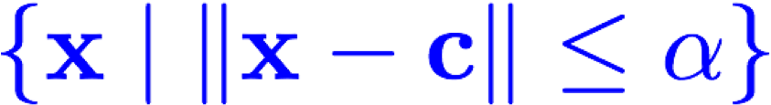Affine sets: 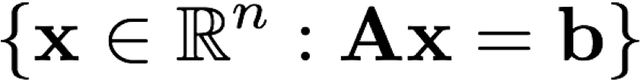

•

Set of PSD matrices

•

Halfspace

:

•

Intersection of convex sets



**True for union?**

•

Norm balls

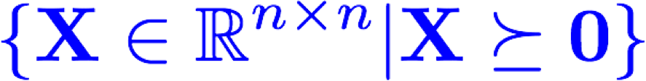

**Change it to infinite?**

**Example:**

**Polyhedron: intersection of finite number of**

**halfspaces**

# Convex Sets

* Affine transformation of convex sets:





* Linear matrix inequalities



* A popular way of representing some convex optimization problems:

